DocuSign Envelope ID: 5B538C60-6ABC-4972-84CD-629A649DE11D

MOU EVENT SPONSORSHIP AGREEMENT

This Memorandum of Understanding is entered into on 9th October,, 2023, by and between Star Innovations Pvt Ltd, Singapore and Amity University Uttar Pradesh, with an address of G8VM+H69, Amity Rd, Sector 125, Noida, Uttar Pradesh 201301, also individually referred to as “Party”, and collectively “the Parties”.

WHEREAS the parties are desirous to enter this Memorandum of Understanding between them, setting out the terms and conditions for the Event Sponsorship.

NOW THEREFORE as per previous interactions of mutual agreements are contained in this Agreement, the Parties hereto agree as follows:

## PARTNERSHIP PURPOSE

* 1. The purpose of this sponsorship is to provide Rs. 10,000/- only for CyberCup 3.0 which will be held on 13th-14 October, 2023 in Amity University Uttar Pardesh.
  2. Company logo and name will be printed on event posters, backdrops, CyberCup 3.0 website, certificates and for all advertisement purposes.

## TRANSFER OF FUNDS

* 1. The Sponsoring party agrees and acknowledges that all payments are to be made through DD/local cheque drawn in favor of Amity Sponsorship Account payable at Noida..

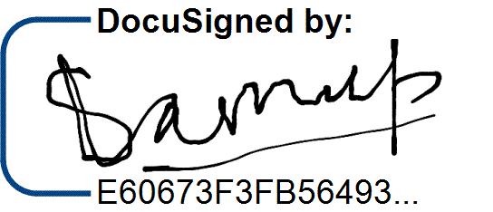The Party agree to the terms and conditions set forth above as demonstrated by their signatures as follows: COMPANY NAME: . Star Innovation Pvt Ltd COMPANY NAME: . . SIGNED: . . SIGNED: . .

# NAME: . Sameep Singhania . NAME: . .

10/10/2023

# DATE: . . DATE: . .